
Fawry Data Engineering Pipeline Analysis

1. Data Sources
Fawry operates one of the largest digital payment networks in Egypt, which means it collects data from several major sources:
- POS Terminals and Agent Network: Payment requests, transaction logs, timestamps, service types, and merchant IDs.
- Mobile App & Website (myFawry): User account data, wallet top-ups, bills, e-commerce payments, and behavioral events.
- Merchant & Corporate Integrations: Invoices, settlements, reconciliation files, and B2B payment data.
- Banking & Financial Partners: Transaction confirmations, settlement reports, and compliance-related data.
- Service Providers (e.g., utilities, telecom): Bill status updates, payment confirmations, and service charges.

2. Storage Layer
Fawry would typically rely on a multi-layer storage architecture to handle its massive transaction volume:
- Data Lake (Raw Storage): Stores unprocessed data from POS, app logs, API events, and external integrations in formats like JSON, CSV, or Parquet.
- Data Warehouse: Cleaned and structured data used for analytics, financial reports, dashboards, and regulatory compliance.
- Operational Databases / NoSQL Stores: Used for real-time operations such as wallet balance checks, instant confirmations, and fraud flagging.
- Cold Storage / Archive: Long-term storage for older transaction logs, audit trails, and compliance data.

3. Processing Layer
Fawry requires both batch and real-time processing capabilities:
- Real-Time Stream Processing: Handles instant validation of payments, fraud detection, balance updates, and event-driven alerts.
- Batch Processing: Daily or hourly ETL/ELT jobs to transform raw data into the Data Warehouse and generate settlement reports.
- Data Cleaning and Enrichment: Removing duplicates, fixing inconsistencies, and enriching transactions with merchant details, geolocation, or service category.
- Aggregation: Creating summary tables for daily transactions, merchant performance, and service usage trends.

4. Serving Layer
Once processed, the data supports several business functions:
- Dashboards & BI Reports: Used by management, finance, and operations to track revenue, transaction volumes, agent performance, and service usage.
- Real-Time Application Services: Wallet balance display, transaction history, instant confirmations, and agent portal updates.
- ML-Driven Features: Fraud alerts, personalized recommendations, transaction risk analysis, and predictive analytics.
- User App / Website: Financial reconciliation, settlement processing, auditing, and compliance reporting.

5. Pipeline
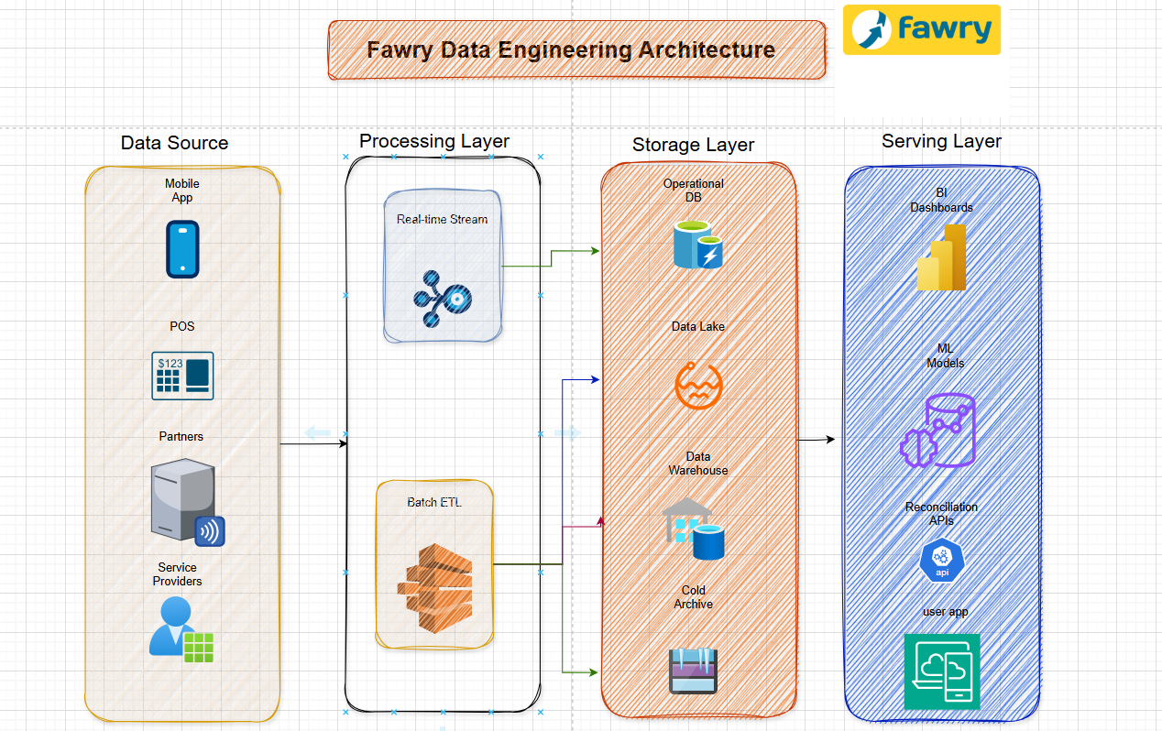

Use Case
Example: Paying an electricity bill through Fawry
- The user pays via agent or the mobile app.
- The transaction is captured instantly and sent to the system.
- Real-time processors validate the payment and update balances.
- The raw transaction is stored in the Data Lake.
- Batch jobs later move the cleaned version into the Data Warehouse.
- Dashboards update with daily transaction volumes and settlement info.
- Utility providers receive confirmation and settlement files.

References
- Fawry Official Website – Company Overview: https://www.fawry.com/about/who-we-are/
- Fawry Partnership Announcements and Transaction Insights: https://www.fawry.com/2025/03/19/fawry-and-contact-join-forces-to-transform-egypts-e-payment-system/
- Fawry – Egypt’s leading digital payments platform
- Fawry for Banking Technology and Electronic Payments - The Middle East’s Fintech 50 - Forbes Lists

